Marketing for Entrepreneurs
Delivered to the Midlands Technical College Fast Trac Program
2/13/2018
Columbia, S.C.

Credibility
Who you are Dr. Kasie Whitener
What you do Process consulting
How you do it The Road Methodology
Why you do it We are all about the “how.”

When I first meet small and start-up business owners, I listen for them to tell me what they do, who they do it for, and why they do it. This is the three-circle diagram detailed by Simon Sinek, author of Start With Why. Here’s a great YouTube video to supplement this diagram.

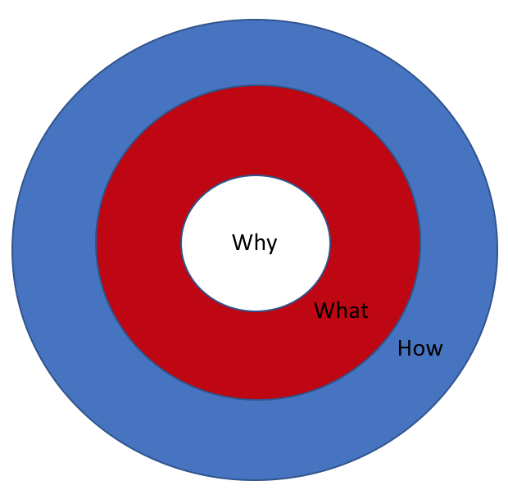

A lot of business owners can tell you their What and How. They may even tell you Who they do it for. Too many can’t tell you Why they’re doing it.

Your Why is your story and it’s the reason people will follow you, help you, and invest in you. Your Why is about your passion, certainly, it’s about your story, certainly, and it’s about the change you want to see in the world. Without a Why, you might as well be working for someone else.

But your Why is functional, too.

Your Why is the problem you’re solving.

So ask yourself, “What problem am I solving?” Because if you’re not solving a problem, you have a hobby, not a business. People who make earrings, what problem are they solving? I have earrings. What’s so special about these? People who make soap or candles or lotion, what problem are they solving?

You’re not a hobbyist, you’re an entrepreneur, so ask yourself:

Who has this problem? – this is your target market. Is it overworked moms? Is it mid-career managers? Is it children on the verge of learning to read? Who has the problem you’re solving? The elderly? Diabetics? People addicted to using their cell phone? Be specific about who has this problem because nobody sells to “everybody.”

Will they pay for your solution? – a lot of people want a problem solved but have no interest in investing in the solution. Think of all the people who want to lose weight but won’t diet or exercise to make it happen. Solutions cost us something. Will the people you’re targeting pay you for a solution?

Can they afford your solution? – willing to pay and able to pay are two different things. People might be willing to pay all day long but not have the money to afford your solution. You only have a business if people are willing and able to pay. Think of healthcare devices, technologies, and services. People are willing to use these but can they afford them? If not, the customer stops being the patient and starts being the payer.

Do they have urgency? – what happens to these people if they don’t adopt your solution? Will they just continue doing things the way they’ve been doing them? Will they get along just fine? Not as great, obviously, as if they had your service or product, but they’ll be okay. If they can be prosperous, healthy, satisfied, or safe without your product or service, then where’s their sense of urgency? You don’t want to have to build urgency in people. You want them to want to spend their money on you.

Market Research
First, let’s be clear about the word “research.” What it does mean is learning something you didn’t already know. It does mean searching, looking, asking, finding, and understanding what you’re seeing. Even if what you’re seeing doesn’t fit with your expectations of the market.

What is does not mean is asking your friends and family if they think you’re on to something. It also doesn’t mean ignoring the evidence that your business idea is a no-go. It also does not mean you’re committing to following the herd. For example, if you do legitimate research on international opportunities and find they really, really need your product in Bangalore, India, that doesn’t mean you have to go to India to be successful. It just means that there’s opportunity there and like all opportunities, you’re free to ignore it.

Local, Regional, National, International?
- Local: your friends, family, people within 1-degree of you, PTA members, neighborhood moms, the usual suspects at a 31 or Bedtime Stories party.
- Regional: in the city, in the county, in the state; customers you don’t know but can drive to visit
- National: in the United States, probably best serviced online but possibly via a strategic travel schedule. Never vacationed at Niagra Falls? Take a drive and stop in the places you find clients on the way up and the way back. Write the whole trip off.
- International: Outside of the United States, also easily serviced via internet, but also a nice opportunity for a tax-deductible vacation. Remember that emerging markets need what we have to offer and if you can build a tribe there, you can sell your product there.

Direct competitors?
- These are the people who do exactly what you do for the people you do it for.

Indirect competitors?
- These are the people who provide something similar to your product or service for your target client; or they provide exactly what you do but for a totally different demographic.

What makes us different?
- We ask our 1 Million Cups presenters this question religiously. Why should your customers buy from you and not one of your competitors? What are you promising that makes you different. Here we’ll use a little Michael Porter. He says companies can do one of three things, not all three. So decide what you’re going to focus on:
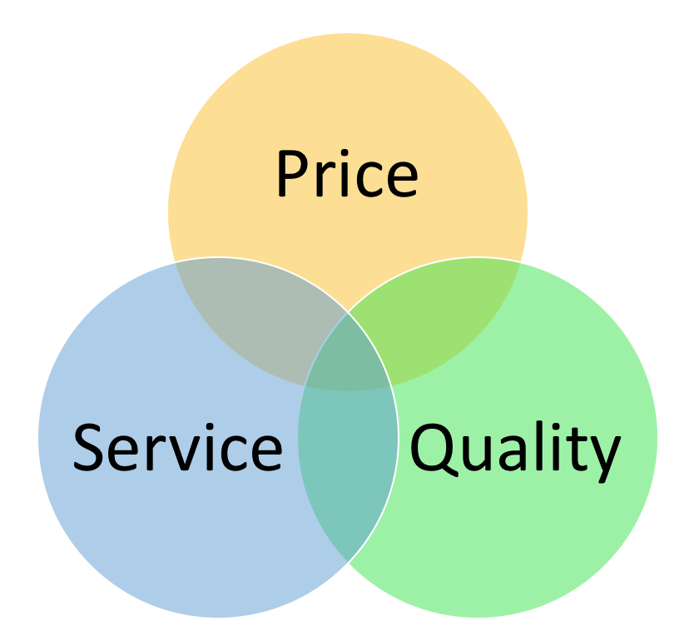

- You can compete on Price – Walmart is the best example but McDonald’s comes to mind, too. Price competition if about reducing the costs in your supply chain so your customer can get something very, very cheap from you. Price competition works on “economies of scale” which means buying in bulk to receive a discount and then passing a discount on to your customer. If you can’t buy in bulk, and most small businesses can’t, then you will have a hard time being a Price-oriented company.

- You can compete on Quality – Apple is the best example but Starbucks comes to mind, too. This focus is about providing the highest-grade in the category. You’re a category leader because your product or service is better than everyone else in your category. When you sell Quality, you’re pricing can be higher because your customers are getting the best ingredients, materials, technology, or innovation.

- You can compete on Service – Zappos is the best example but Men’s Wearhouse is another good one. Service as a differentiator is about processes. In Zappo’s case, they make it really, really easy to return items you’ve purchased but are unhappy with. Their customer service on the return process is so great, people will continue to take a chance on buying clothing and shoes without trying these items on (gasp!). Buyers don’t know how the material feels, how the shoe fits, or if the hang of the skirt is too low. Zappos cultivates item reviews and maintains a generous return policy because you can buy clothes online anywhere, but they’re competing on Service, not price or quality.

How will we deliver our services/products?
- Your business plan should include a comprehensive description of how you plan to meet your customers’ needs. In consulting, this is our methodology, but in products it’s your materials and supply chain, your construction or manufacturing, and your sales processing and fulfillment. You must know how you plan to get the product in your customer’s hands or you’ll underprice and probably under-deliver.

Sales & Distribution
A lot of our 1 Million Cups presenters want our community’s help with “spreading the word.” They are looking for referrals, they want to be introduced to clients, they want us to help them find their customers. Really, they need to go sell something. More on that in a bit.

Do you have a complete solution?
- If the answer to “What problem are you solving?” is followed by your complete solution, then you’re good to go. One of our clients sells advanced chemistry technology, pipettes for extractions to be specific. They want to get into the Pharmaceutical industry but Phara companies don’t do anything by hand; everything is robotic. I said, “Do you sell robots?” They said, “No.” They don’t have a complete solution for the Phara industry. That’s okay, they don’t need to throw in the towel. Keep reading.

Where are your customers?
- This is not a market question (local, regional, etc.) this is about where are your customers in their problem. Are they in need of a complete solution? Or can they make do with your product without the rest of it? For example, if you’re selling a weight loss tonic and your customers are already exercising and dieting, then your tonic may be just that last element they need. But if they’re expecting to just drink your smoothies without lifting a weight or giving up buttered popcorn, they may need a full weight-loss plan – a solution. We had a Kambucha company present at 1MC and she talked about the overall health benefits of Kambucha. But it’s not, in itself, a full wellness solution. Diet changes, lifestyle changes, meditation, reflection, all of these different behaviors complement Kambucha. So how does she “solve” her customer’s health problem?

How can you get there?
- Can the Kambucha lady also become a life coach who prescribes daily meditation and reflection and takes up walks or other fitness efforts with her buyers? No, she’s too busy brewing Kambucha to sell by the gallon. You might be able to expand your product or service offerings to create a complete solution. Give some thought to what they would look like. No one says you have to do that, but thinking about it might give you some idea of a long-term scale or growth plan. Alli Webb of Drybar says the next phase of their business is in hair care products. They have 60+ products on the market and are using the success of the salons to grow that secondary source of revenue and the “complete” solution. Eventually they may see an appointment-setting technology, a stylist training academy, or a professional photography session expansion as additional pieces to the solution they’re offering.

What partnerships are available?
- If the complete solution is outside your expertise, capabilities, or interests, you can still market it by joining hands with partners who offer the elements you’re missing. Find companies, products, and people you want to team with to address your constituents and market a complete solution. Partnerships don’t have to be legally binding, they can be short-term promotions, appearing together at events, or just cross-promoting on social media. But select a provider and make that the one you recommend to your customers. Then get that provider to reciprocate.

How can you connect others?
- When fishermen throw a net, they inevitably end up with sea creatures they can’t sell. While marketing your product, the wrong customers will stumble onto your website, social channels, or even into your store. Don’t tell them you can’t help them. Find someone who can. When you meet their needs, even if it’s just through a referral, you’re putting good kharma into the world, kharma that will come back to you. Connect people with the solutions they need, even if it’s not yours, and you’ll score a point on the assist.

Showing Up. The 80%.
I told you we’d get back to sales. Marketing is important. Marketing is valuable. Marketing can help you get the right message to the right people. But in the end, Sales is what drives business. You have to sell something. In the first few years of a business, that sales channel can look like a bull riding competition. Who will buy? What can I sell them? Don’t get discouraged by the iterations of your product or service is undergoing. If you’re changing for the markets you’re entering, then you’re responding to the needs, solving the problems, and earning experience and credibility as you go. Sales is about fluidity and responsiveness.

Be where they are.
Ask questions.
Make connections.

Options for exposure
All those “networking” things you do
- On line
  - Social media personality: let your social channels have a voice, someone your customers want to hear from, want to engage with; outline this personality and be intentional about it.
  - be interested, not interesting: be in the places where your customers are and ask questions, congratulate achievements, and suggest opportunities; share successes and give back-pats and thumbs-up
- On Site
  - community participation: find your tribe, join up with organizations that can help you grow as a person, give back to your community, and provide you with opportunities to serve. They can be peripheral to your industry, or completely outside of it, but use community involvement to help you practice talking to strangers, pitching your business, and learning about others.
  - volunteer, promote, share: leading your company can be a challenge, but leading a volunteer organization is a great way to get experience at it before you ever make the first hire; share and promote the events, work, and people in organizations you admire or want to do business with. Show up to their ribbon cuttings, meetings, happy hours, and charity things. Show them you support them and their mission and they’ll support you and yours.
- On Stage
  - be like the chefs: You know why Emeril Legasse goes on television and shows you the ingredients, tools, and techniques to create the amazing dishes he makes? Because he knows you can’t do it. His knowledge is 20+ years in the making and you’re just watching a video. “Be like the chefs” is marketing advice from a book called “Rework” about a software company that decided to revise how they thought about relating to customers and employees. It’s totally worth a read. Our company, Clemson Road Creative/Consulting has the Backstage page on our website where we share all of our presentations, notes, and relevant links. (That’s where you found this.)
  - co-lead, facilitate: Finding someone to present with is one of the most rewarding ways to go on stage. Participating in panel discussions, co-leading workshops, and even facilitating conversations are all ways to share the spotlight and demonstrate your expertise to a captivated audience.

Focus Your Efforts
Inventory your efforts and determine the return-on-investment or ROI
Your time is valuable. The amount of it you spend on marketing should be tracked so you can determine whether your efforts are delivering results.

In content marketing, have a mix of How, Wow, and Now content.
- How: demonstrate how to use your product, give away your secrets (be like the chefs), educate people and they’ll keep coming back; see monster.com for evidence of this (“How to land an interview” “How to dress for an interview” “How to follow up after an interview” it’s endless).
- Wow content is your bragging rights. Did you win an award? Present at an industry event? Partner with someone key in your industry? Win a big contract? The WOW content is what makes your followers excited about being in your tribe and gets non-followers curious. The
- Now content is about relevance. How does your product or service fit into the current news landscape? Is there an article about cyber security in government agencies you can share? Does your business help government agencies address that vulnerability? That’s a Now content share. Is there an article about the importance of getting a flu shot while your traveling medical services deliver flu shots onsite at corporations as a benefit to their employees? That’s a Now content share.

Measure often and be honest with yourself.

Doing your marketing inventory should not be an annual thing where you look up and say, “Oh, yeah, Twitter was good for a while but then we just got slack about it…” If you’re checking in often on your marketing efforts, then you’ve also 1) created a schedule for yourself and are keeping to that marketing task schedule so you know where to tweak; and 2) know what you absolutely hate to do in marketing and know what to eliminate.

Be honest about what you love to do and what you hate to do. If you hate it but it works, then find a way to love it or find someone else to do it for you. If you hate it and it isn’t working, stop doing it. Your business will not shut down because you don’t have Facebook. I promise.

Your Marketing Mix
Do what you’re good at, what works, and what you enjoy. In that order.

Be where your customers are.
Be the brand you're meant to be.
Do what you're best at.
Find, do, measure, revise, repeat.

